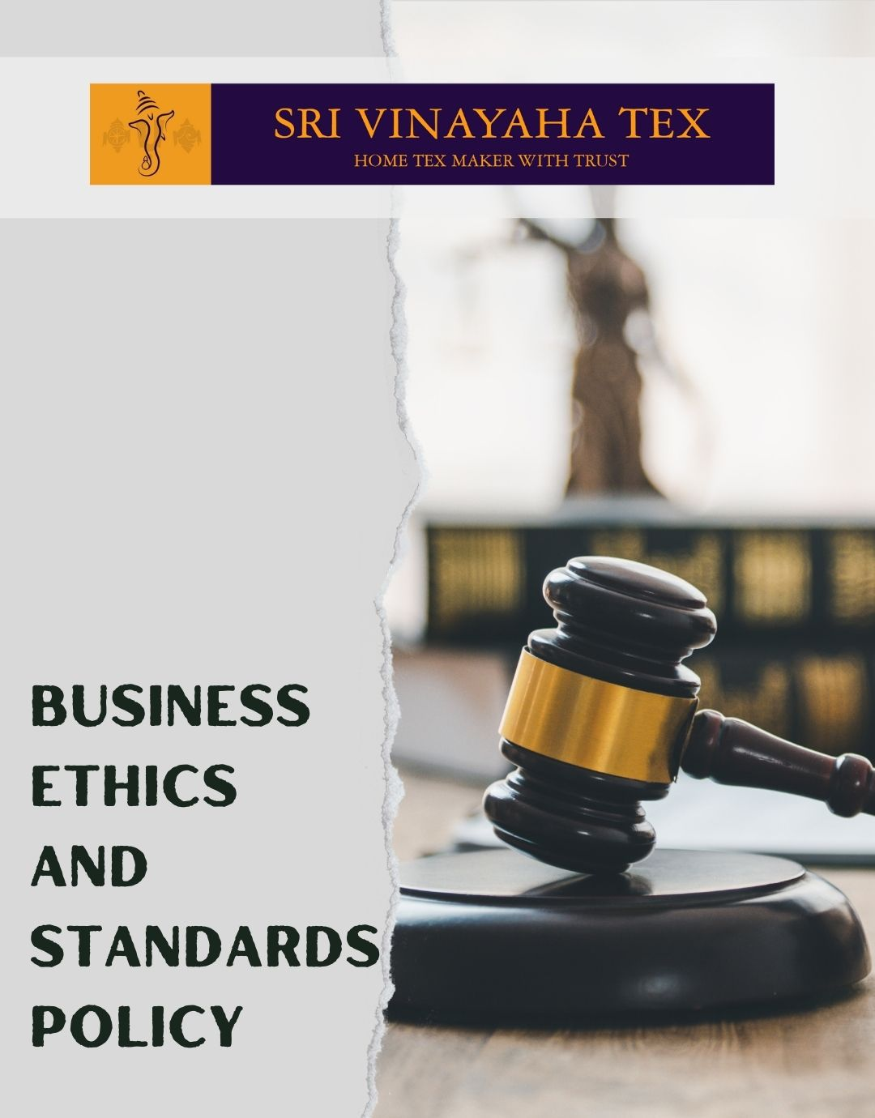

TABLE OF CONTENTS
PROLOGUE 2
SCOPE 2
POLICY DECLARATION 2
INITIATIVES AND TARGETS IN ALIGNMENT WITH SDGs 3
PERFORMANCE REPORTING 4
REVIEW MECHANISM 5

PROLOGUE

At Sri Vinayaha Tex, our commitment to integrity, transparency, and fairness is fundamental to our operations. Our Business ethics and standards Policy is designed to uphold these values by ensuring that all employees, suppliers, and stakeholders adhere to the highest ethical standards. This policy provides a clear framework for addressing key ethical issues, such as corruption, conflict of interest, and fraud, while fostering a culture of openness and accountability.
We are dedicated to implementing preventive measures, offering training, and maintaining transparent reporting mechanisms to promote ethical behavior and compliance. By adhering to these principles, we aim to build trust, protect our reputation, and ensure that our business practices meet legal and moral expectations.

SCOPE

This Policy is applicable to following sites and all of its employees, workers, sub-contractors and other stakeholders:

Sr. No. | Site | Address
1 | SHRI VINAYAHA TEX
2 | SHRI VINAYAHA TEX

POLICY DECLARATION

Sri Vinayaha Tex is dedicated to upholding ethical conduct in all operations, expecting every employee, manager, and partner to adhere to our core values of honesty, fairness, and respect. Adherence to this policy is mandatory, and any violations will be addressed with appropriate disciplinary actions, which may include formal reprimands, mandatory retraining, or, in serious cases, termination of employment or business relationships. This approach ensures that our ethical standards are maintained consistently across all levels of the organization. We consider 2023 as our baseline year for evaluating and enhancing our ethical practices and compliance.

INITIATIVES AND TARGETS IN ALIGNMENT WITH SDGs
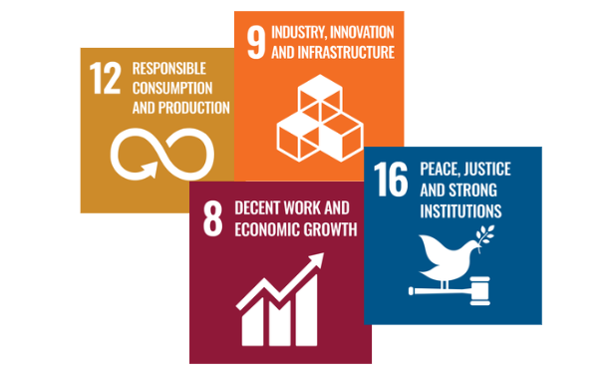

- Implement and maintain anti-corruption training programs for all employees to enhance awareness and understanding of corruption-related risks and prevention measures.
- Achieve a 100% completion rate for anti-corruption training among all current and fresher employees by year 2030.
- Develop a comprehensive conflict of interest declaration form for all employees and suppliers to disclose any potential conflicts.
- Conduct quarterly reviews of conflict of interest disclosures and resolve 95% of cases within 30 days.
- Establish a fraud prevention and detection system with clear procedures for reporting and investigating suspected fraud.
- Reduce the number of reported fraud incidents by 20% through enhanced controls and awareness programs by year 2030.
- Create a confidential and secure whistleblower hotline and support system to encourage reporting of unethical behavior without fear of retaliation.
- Achieve a 100% satisfaction rate in annual employee surveys regarding the effectiveness and confidentiality of the whistleblower protection system by year 2030.
- Implement an anti-money laundering (AML) policy that complies with local and international regulations.
- Achieve 100% completion of AML training for new employees within 45 days of hire.
- Conduct periodic audits to ensure compliance with anti-competitive regulations.
- Achieve 100% compliance with anti-competitive practices policy among all departments by year 2030.
- Ensure that all marketing materials are reviewed for compliance with ethical standards.
- Decrease customer complaints related to unethical marketing by 40% by year 2030
- Establish and maintain an information security management system (ISMS) in accordance with international standards (e.g., ISO 27001).
- Conduct regular information security awareness training for all employees.
- Achieve 100% compliance with ISMS requirements during annual audits by year 2030.

PERFORMANCE REPORTING

Performance against these targets will be meticulously reviewed and reported annually to senior management and stakeholders. The detailed reports will include a comprehensive summary of achievements, highlighting areas where targets have been met or exceeded. They will also identify areas needing improvement and provide actionable plans to address any deficiencies. This process ensures transparency and accountability, allowing us to assess our progress, make informed decisions, and continuously enhance our ethical practices and compliance.

REVIEW MECHANISM

This policy will be reviewed annually by the Chief Compliance Officer to ensure its effectiveness and relevance. Updates will be made as necessary to reflect changes in laws, regulations, or company practices. Employees are encouraged to provide feedback and report any concerns regarding the policy to the Chief Compliance Officer, who will ensure that all feedback is considered for continuous improvement.

REV. No. 01

EFFECTIVE FROM: 01.01.2024 NEXT REVIEW DATE: 01.01.2025
APPROVED BY: PRESIDENT - OPERATIONS

